1. 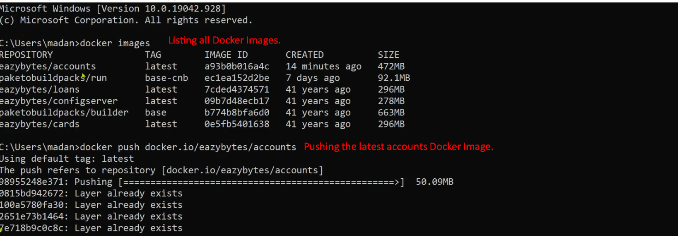
2. Similarly push other latest Docker Images for loans, cards to the Docker Hub.
3. 